诚信应考,考试作弊将带来严重后果！
_____________ ________
…

姓名 学号
学院 专业 座位号
( 密 封 线 内 不 答 题 )
……………………………………………………密………………………………………………封………………………………………线……………………………………线………………………………………

华南理工大学期末考试
《电路与电子技术》（双语）试卷A
考试时间：120 minutes Date：January, 15, 2013
注意事项：1. 考前请将密封线内填写清楚；
2. 所有答案请直接答在答题纸上；
3．考试形式：闭卷；
4. 本试卷共 11 大题，满分100分， 考试时间120分钟。
题 号 | 1 | 2 | 3 | 4 | 5 | 6 | 7 | 8 | 9 | 10 | 11 | 总分
得 分
评卷人

1. Consider the circuit shown in Fig.1 given that U_{S1}=6V, U_{S2}=10V, R₁=4Ω, R₂=2Ω, R₃=4Ω, R₄=1Ω, R₅=10Ω. Find the value of I₁, I₂, I₃, I₄, I₅ and V_{AB}. （6 scores）
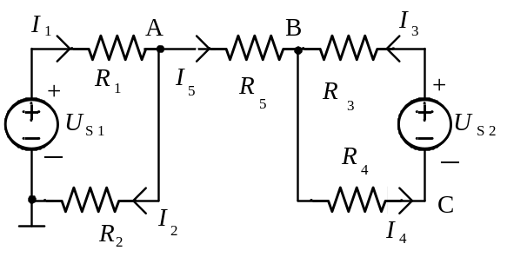
Fig.1
I1=I2=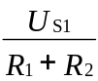=1A 2
I3=I4=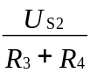=2A 4
I5=0A 5
VAB= 0V 6

2. Consider the circuit shown in Fig.2, the two ideal diodes are of the same type, vi=6sinwt V, please judge the state of D₁ and D₂ (on or off) and plot the waveform of voltage v_{O}. （6 scores）
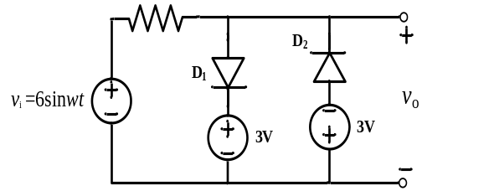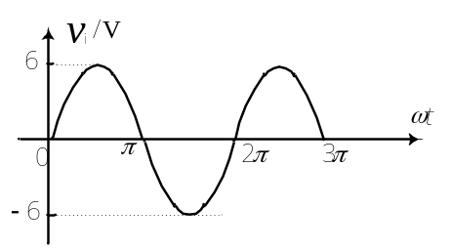
Fig.2
1. When v_{i}>=3V, D₁ on, D₂ off,v_{o}=3V
2. When v_{i}<=-3V, D₁ off, D₂ on,v_{o}=-3V
2. When -3<v_{i}<=3V, D₁ off, D₂ off,v_{o}=v_{i}
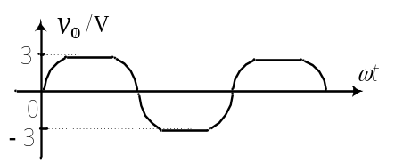
3．Consider the circuit shown in Fig.3 given that U_{S}=1V, I_{S}=1A, R₁=R₂=R₃=1Ω. Determine current I₁, I₂ and voltage U in superposition, which elements are supplying power? （8 scores）
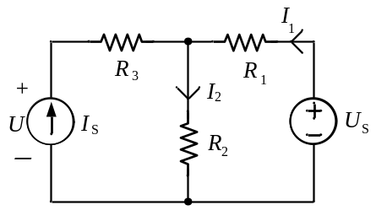
Fig.3

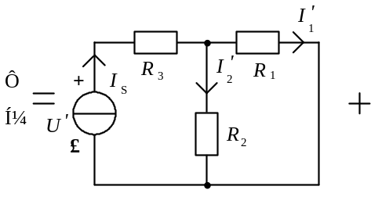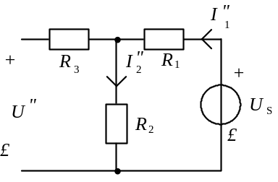
ISacts alone：I1'=I2'=0.5IS=0.5A
U'=R3IS+R2I2'=1.5V 2
USacts alone：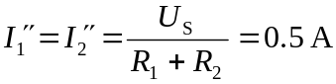
U"=R2I2"=0.5V 4
so：I1=－I1'+I1"=0I2=I2'+I2"=1A
U=U'+U"=2V
电流源IS是电源 8

4．Find the Thevenin equivalent circuits for the two-terminal circuit shown in Fig.4 given that R₁=R₂=2kΩ, R₃=0.4kΩ.（10 scores）
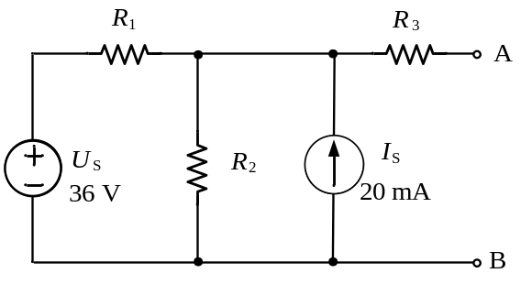
Fig.4
原电路化为下图：
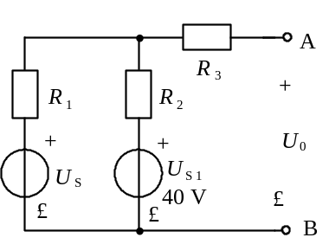
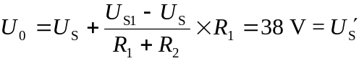 6
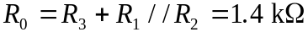
等效电压源电路如下图所示：
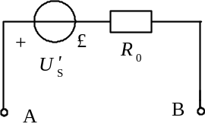 10

5. Consider the circuit shown in Fig.5 given IS=9mA, R1=6kΩ, R2=3kΩ, C=2μF. The switch S has been open for a long time, and then closed at t = 0, please find the 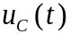after S is closed. (10 scores)
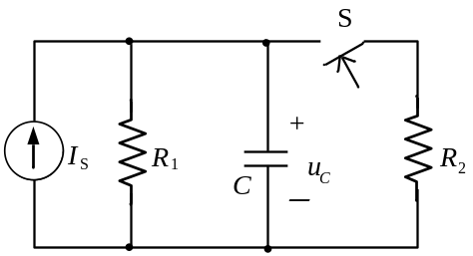
Fig.5
2
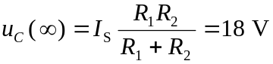 4
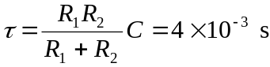 6
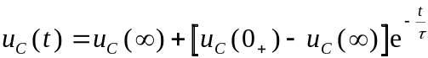
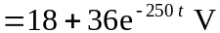 10

6. Consider the sinusoidal circuit shown in Fig.6 given that R=8Ω, XL=6Ω, I1rms=I2rms=0.2A. Find the value of Irms, Vrms, the power factor and reactive power of the total circuit. （10 scores）
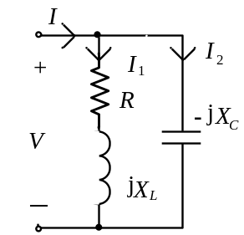
Fig.6
Assume： 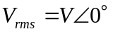 1
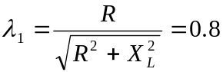
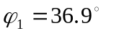then: 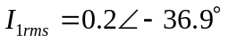A
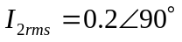A,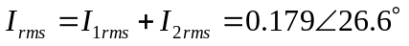A
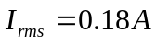 5
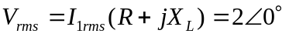 7
Power factor: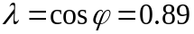 8
Reactive power: 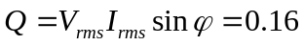Var 10

7.A balanced positive-sequence wye three-phase source has line-to-line voltages of 380V rms. this source is connected to a balanced wye-connected load in Fig.7. Each phase of the load is Z=3- j4Ω. Find the instantaneous current of ia_{A}, ib_{B}, ic_{C}, iNn ,the apparent power, average power and the reactive power delivered to the load. Assume that the phase of V_{ab} is zero. （10 scores）
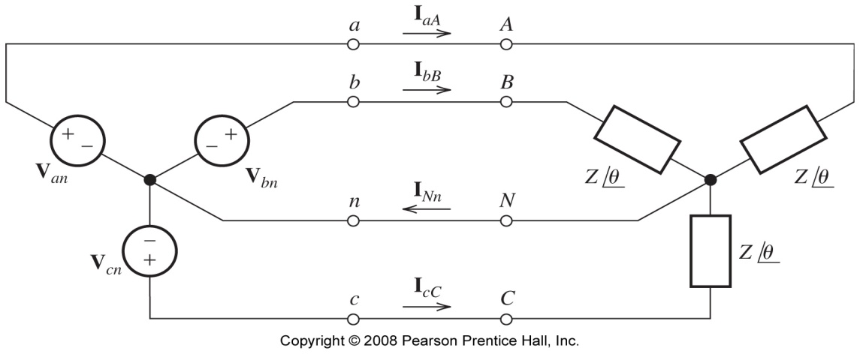
Fig.7
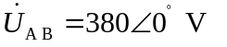 (有效值相量)
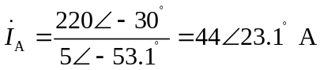 2
4
各线电流瞬时值
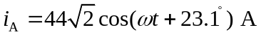
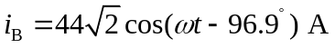
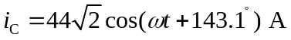
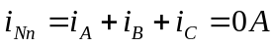 7
apparent power
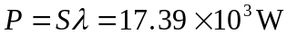 average power
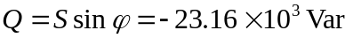 reactive power 10

8. Consider the circuit shown in Fig.8 given that R₁=R₂=R₃=10kΩ, R_{F}=20kΩ, u_{I1}= 1V, u_{I2}= 2V, u_{I3}= -1V,. Find the value of output voltage u_{O}. （10 scores）
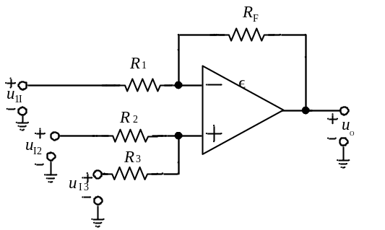
Fig.8
利用叠加原理
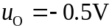
要点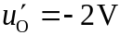(只有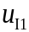输入)
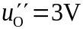(只有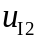输入)
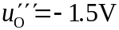(只有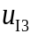输入)
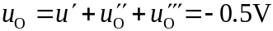
9.Transistors are operating in the active region in Fig.9, assume that: β=50, r_{π}=1kΩ, determine：（1）plot small signal equivalent circuit；（2）calculate input resistor r_{i} and output resistor r_{o}；（3）voltage gain A_{u}. (12 scores).
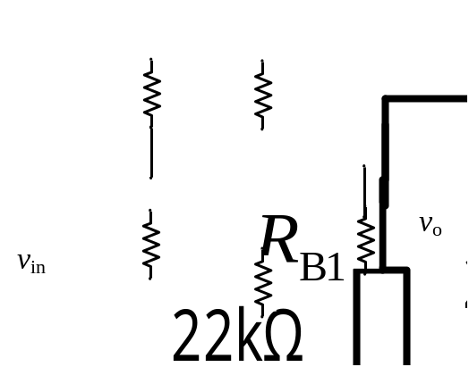
Fig.9
(1)
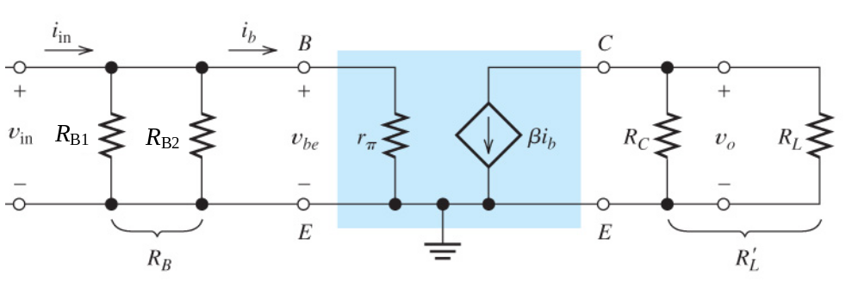4
(2) ro=Rc 4
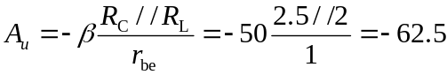 4
11. Consider the source follower illustrated in Figure 10, determine: (1) plot small signal equivalent circuit; (2) Compute the voltage gain, input resistance, and output resistance. (10 scores)
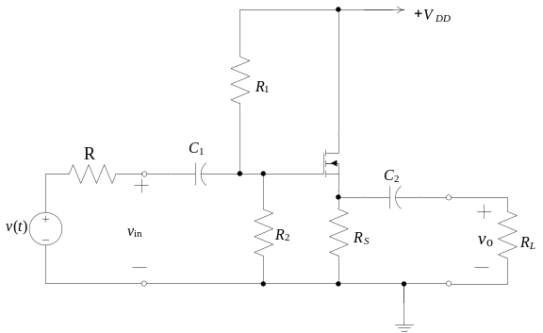
fig.10
SOLUTION
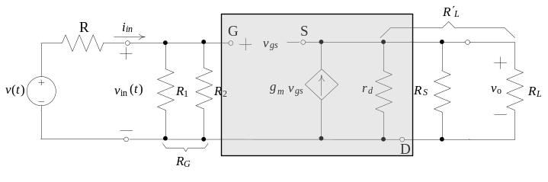4
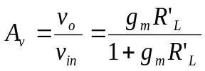 6
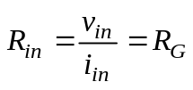 8
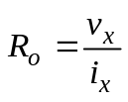
11. Consider the circuit shown in Fig.11, write the logic formula and make simplification in De Morgan’s law, analyze its logic function. (8 scores)
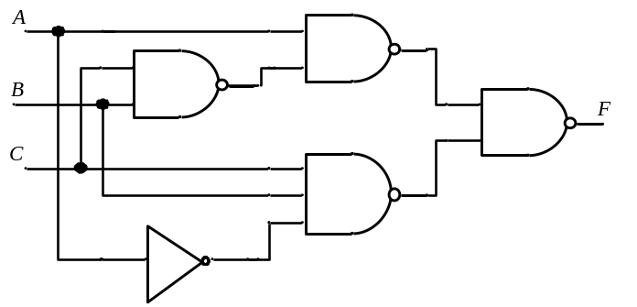
Fig.11
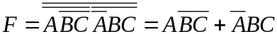
由上式可看出，此逻辑电路功能为A和BC异则F＝1，即“异或”电路.

